Application Form
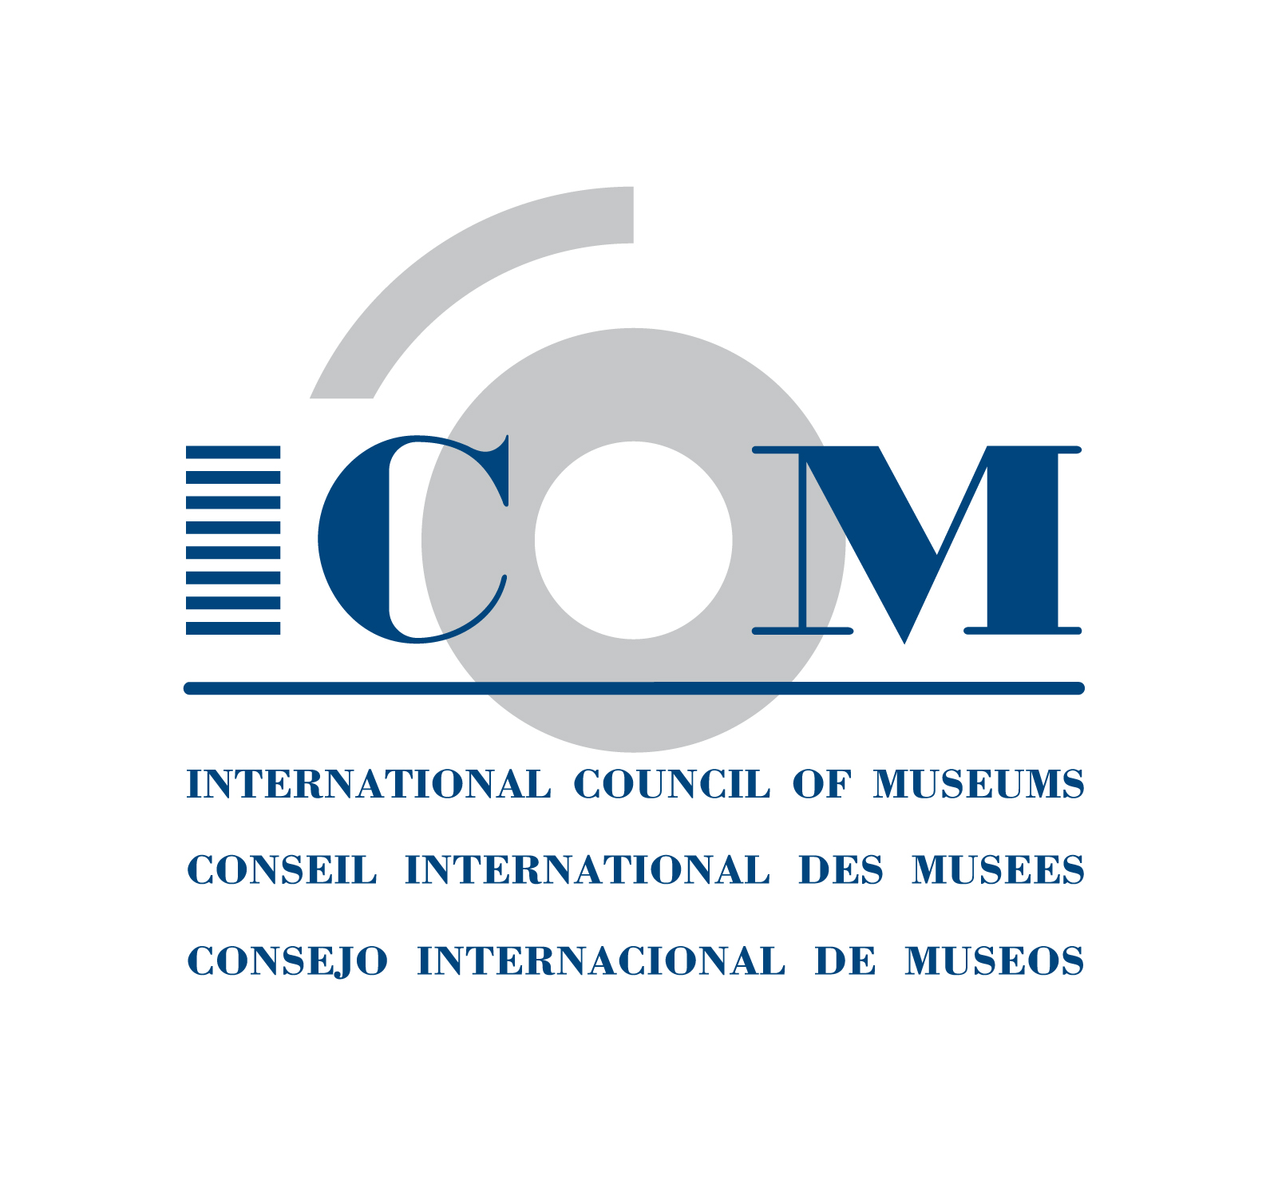
INTERNATIONAL COMMITTEE

MEMBERSHIP
(July 2010)

If you wish to become a member of an International Committee with full voting rights
Please complete and return this application form to :

ICOM Secretariat
Maison de l'UNESCO - 1, rue Miollis - 75732 Paris Cedex 15 - France
Tel.: +33 (0)1 47 34 05 00 - Fax: +33 (0)1 43 06 78 62
Email: secretariat@icom.museum - http://icom.museum/internationals.html

Archaeology & History (ICMAH) | Ethnography (ICME) | Museology (ICOFOM)
Architecture & Museum Techniques (ICAMT) | Exhibition Exchange (ICEE) | Museum Security (ICMS)
Arms & Military History (ICOMAM) | Fine Arts (ICFA) | Museums of Cities (CAMOC)
Audio-visual & New Technologies (AVICOM) | Glass | Musical Instruments (CIMCIM)
Conservation (ICOM-CC) | Historic House Museums (DEMHIST) | Natural History (NATHIST)
Decorative Arts and Design (ICDAD) | Literary Museums (ICLM) | Regional Museums (ICR)
Collecting (COMCOL) | Management (INTERCOM) | Science & Technology (CIMUSET)
Costume | Marketing & Public Relations (MPR) | Training of Personnel (ICTOP)
Documentation (CIDOC) | Memorial Museums (IC MEMO) | University Museums (UMAC)
Education & Cultural Action (CECA) | Modern Art (CIMAM)
Egyptology (CIPEG) | Money & Banking Museums (ICOMON)

Committee Chosen: [ONE ONLY]

Surname: Mr/Mrs/Miss/Ms/Dr/Prof First Name:

ICOM Card Number:

I am: □ An Individual ICOM Member
□ Representing an Institutional ICOM Member
➔ Institution's Name:

Position:

Specialisation/collection:

Professional Address:  City: _____________________ Zip Code:  Country: | Tel:  (Please indicate country and area code)  Fax:  Email:  Web site:
Mailing Address (if different from above):  City: _____________________ Zip Code:  Country: | Tel:  (Please indicate country and area code)  Fax:  Email:  Web :

Date: Signature:

